SQL 50-day challenge:

Challenge1: Mr. Ram wants to go for a movie along with his family. He wants to book three consecutive seats. Can you help him get the list of **3 or more consecutive empty seats**?

[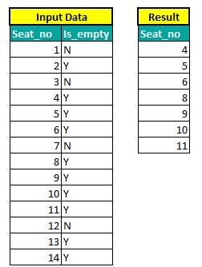](https://as-prod.asyncgw.teams.microsoft.com/v1/objects/0-sa-d2-278007a1df19d87648c6c57c3b15df73/views/imgo)

**Challenge2:**

We are given a table, which is *Binary Search Tree* consisting of two columns **Node** and **Parent.** Write a Query that returns the node type order by value of nodes in ascending order.

](https://as-prod.asyncgw.teams.microsoft.com/v1/objects/0-sa-d2-d3859255fdbd34a7c8243e93f6fe148e/views/imgo)

Root-If the node is a root  
Leaf-If the node is a leaf  
Inner-If the node is neither root nor leaf.

**Challenge3:**

**Restructure the table.**

](https://as-prod.asyncgw.teams.microsoft.com/v1/objects/0-sa-d3-a775ce9ea8ed9938246e8ebd47cda855/views/imgo)

](https://as-prod.asyncgw.teams.microsoft.com/v1/objects/0-sa-d8-3030147361d46b41a7046314c5158411/views/imgo)